# Feature – Find a Doctor (Krunal)

Find a doctor is a feature with the help of which a registered user can search a doctor by name or by their specialty. Visitors to the website will be required to login to see the link. A patient can also view full profile of a doctor including his email and phone number. From that there is a make an appointment link with which patient can book an appointment.

The feature has admin view too. An admin can view all the doctor records, also he can insert a new doctor when he joins the hospital. When an information needs to be deleted or changed, admin can do that too.

|  |  |
| --- | --- |
| Primary Key | Numeric |
| Username | Varchar(50) |
| Date of Birth | Date |
| Identification | Varchar(50) |
| Department | Char(50) |
| Join Date | Date |
| Specialty | Varchar(50) |

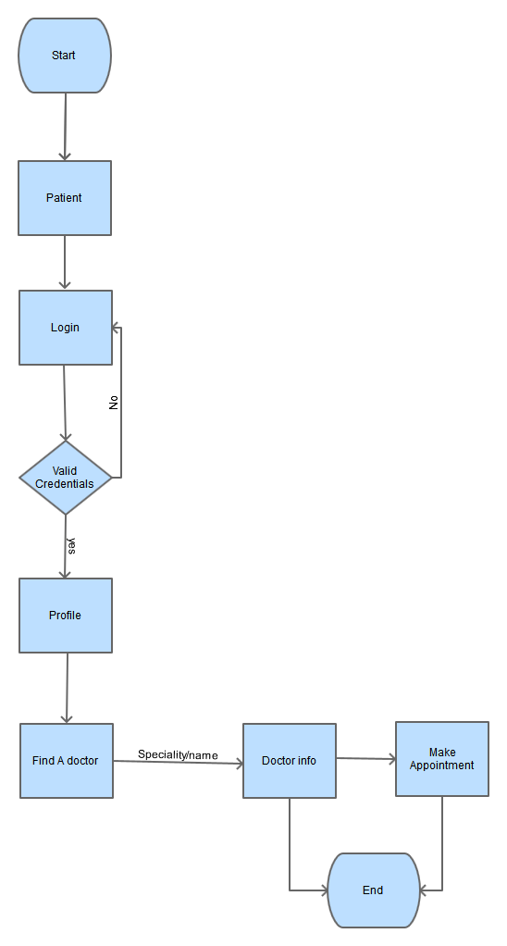

**Flow chart Find-a-Doctor User View**

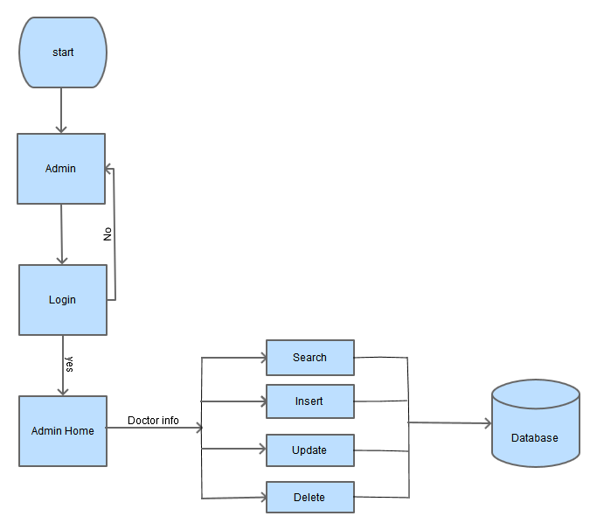

**Flow chart** **Find-Doctor-Admin View**

**Wireframes**

**User view:**

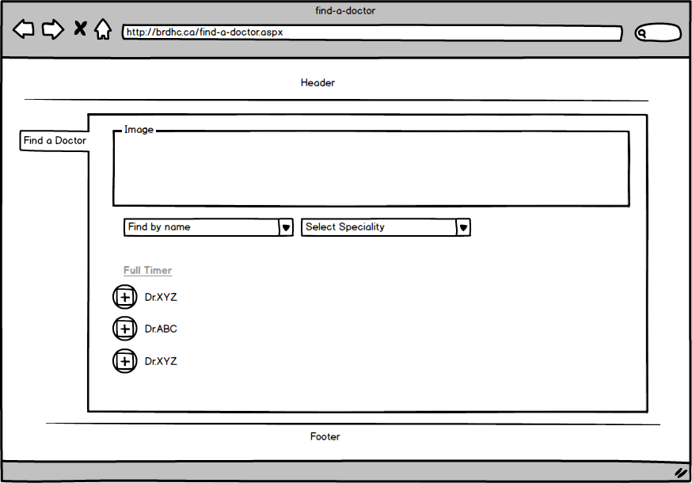

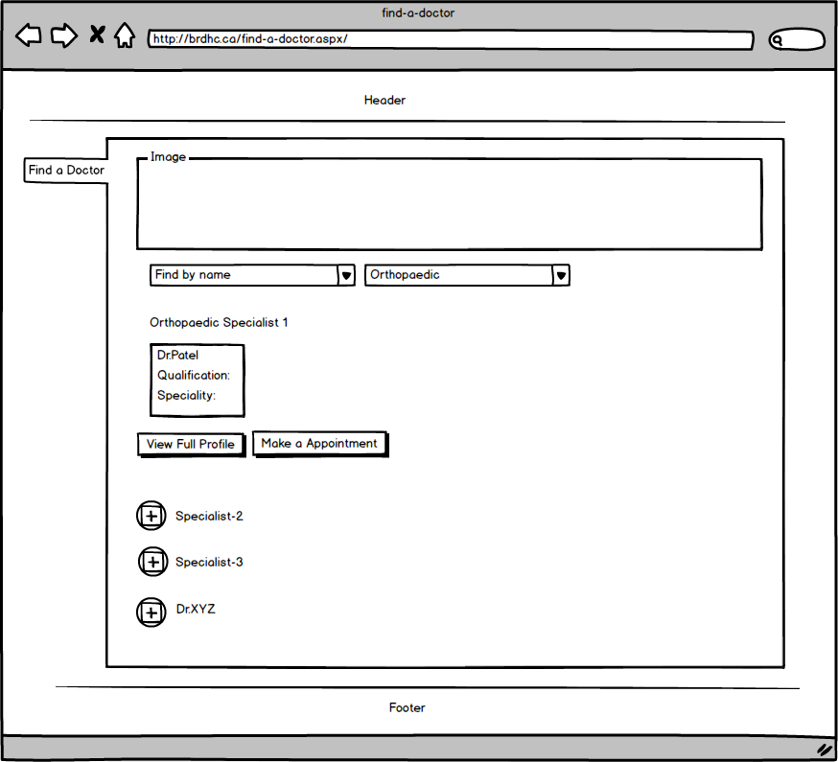

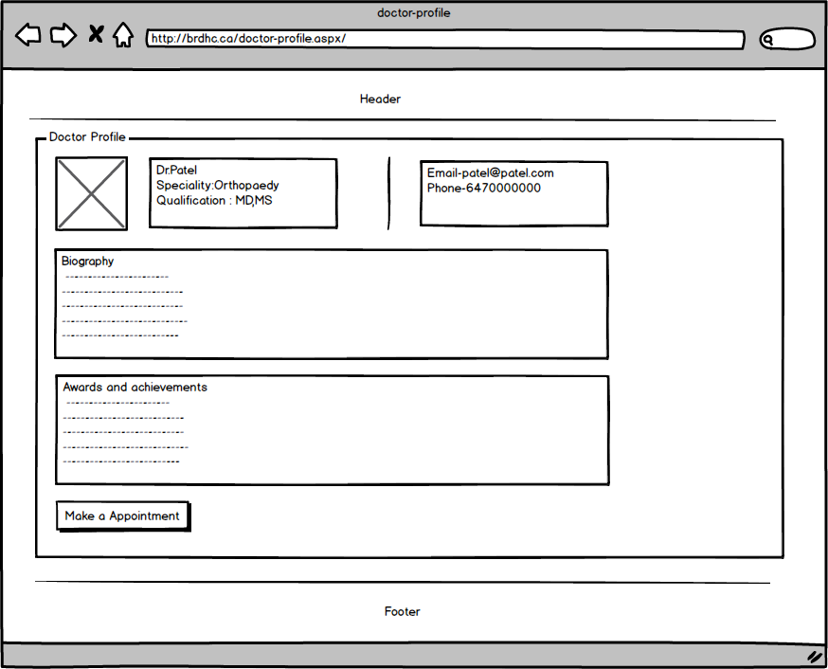

**Admin view:**

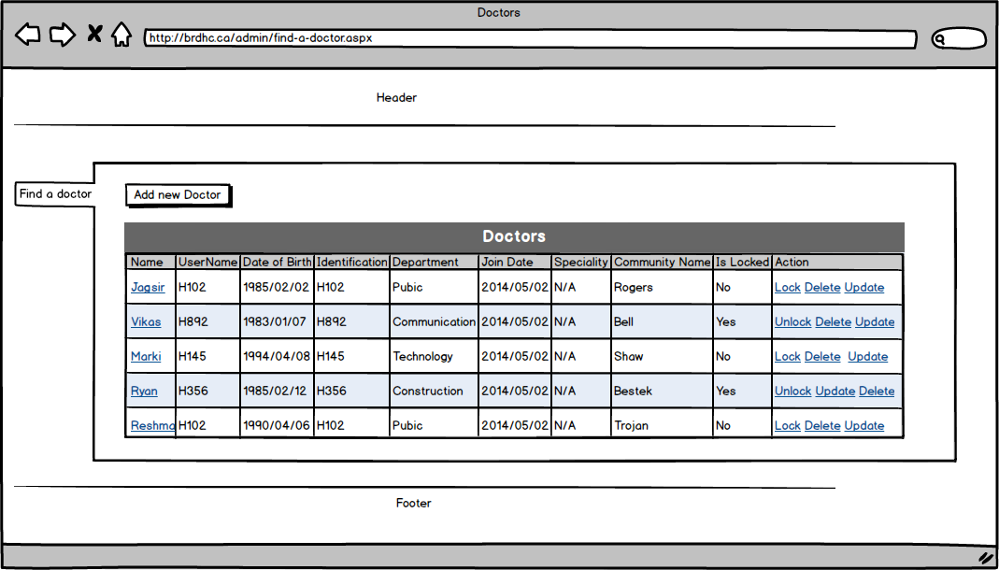

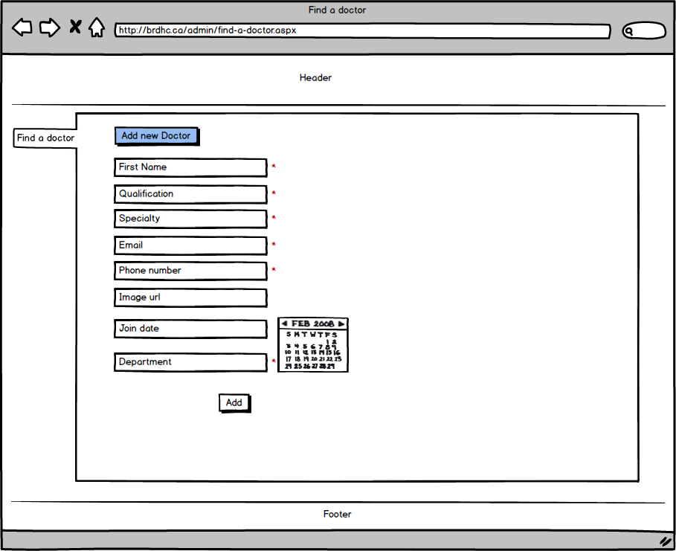

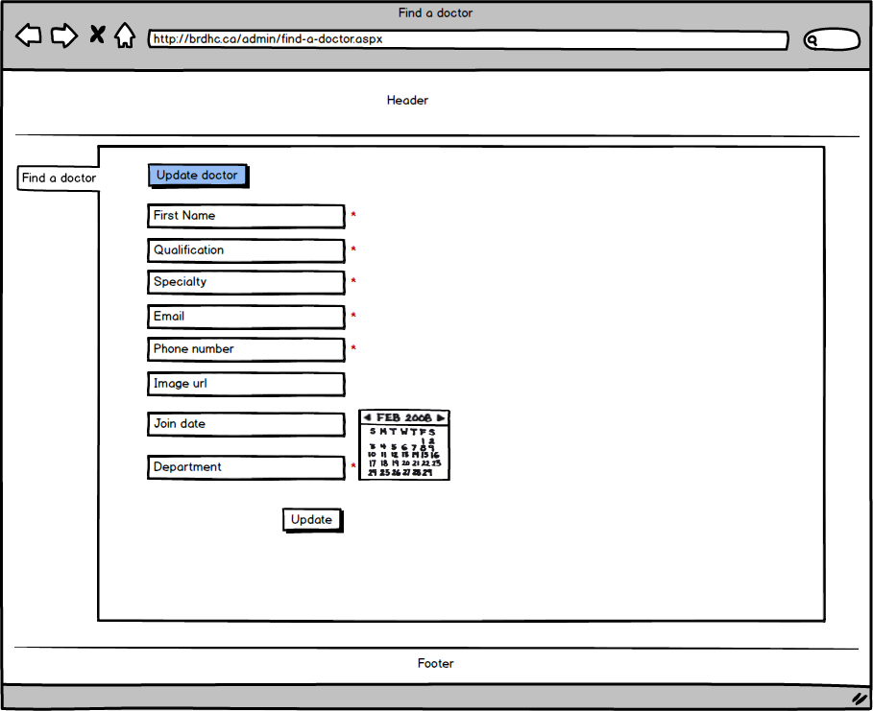

# Feature Make a Donation (Krunal):

This feature also has two views. Admin View and User View. A user who is interested in donating money can donate money through secure online process. He/She can donate to the specific department of the hospital. The donation process uses Sandbox (PayPal) for secure online transactions. When User completes the donation process an automated tax receipt is generated and the information is stored in the database.

On the Admin side, one is able to view the records of the donor’s and delete the records if required. A direct email can be send to the donor if required.

|  |  |
| --- | --- |
| Primary Key | Numeric |
| Name | Varchar(50) |
| Gender | Char(10) |
| City | Varchar(50) |
| State | Varchar(50) |
| Mobile | decimal |
| Email | Varchar(50) |
| Amount | Decimal |

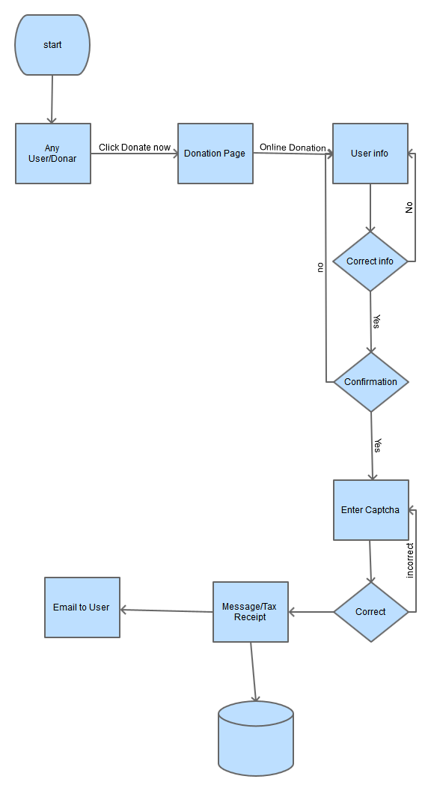

**Flow chart** **Make a Donation User view**

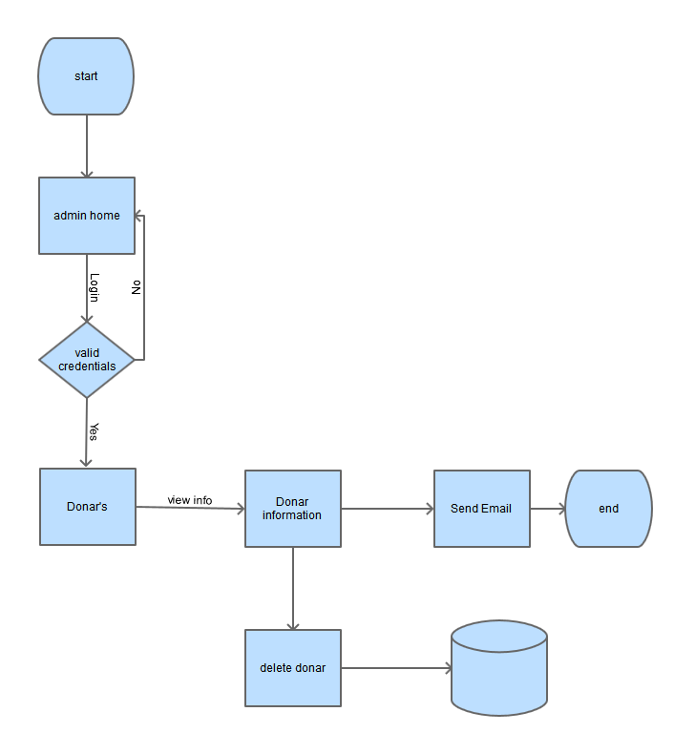

**Flow chart** **Make a donation Admin view**

**Wireframes:**

# **User view**

# C:\Users\Krunal\Desktop\Wireframes\krunal-Donation1 UserView.png

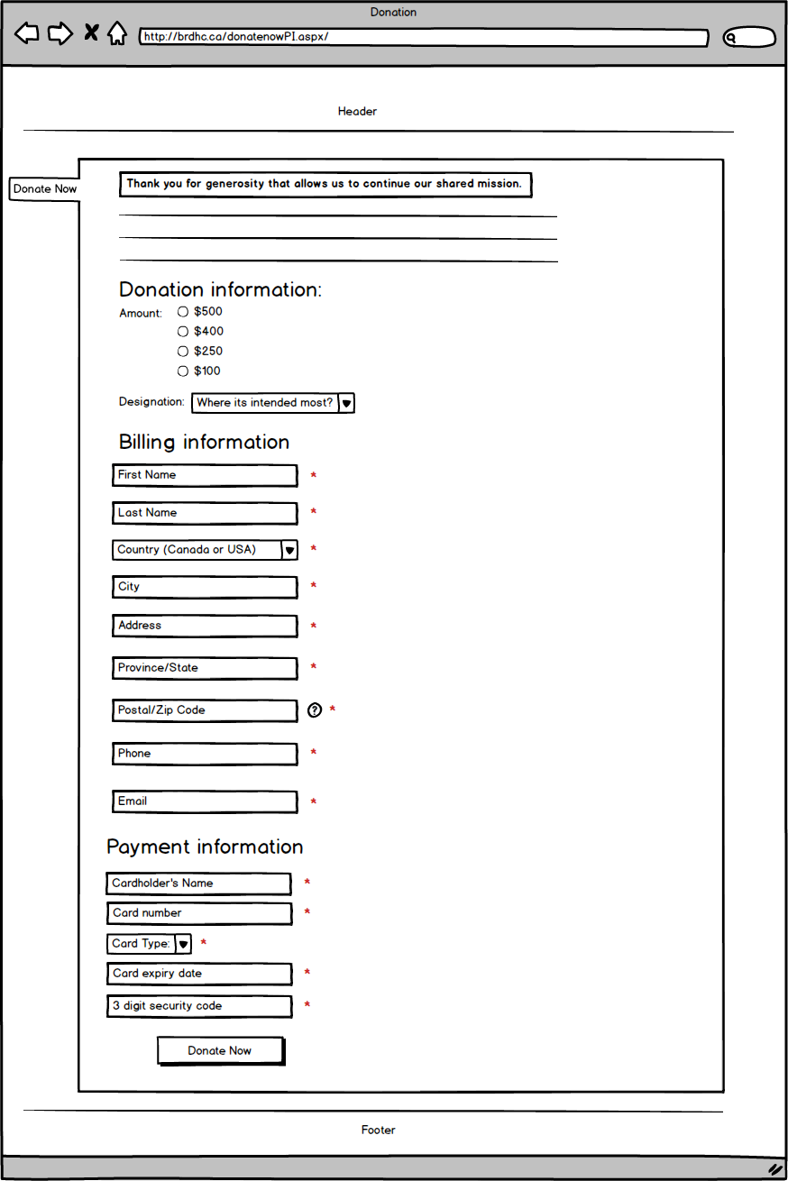

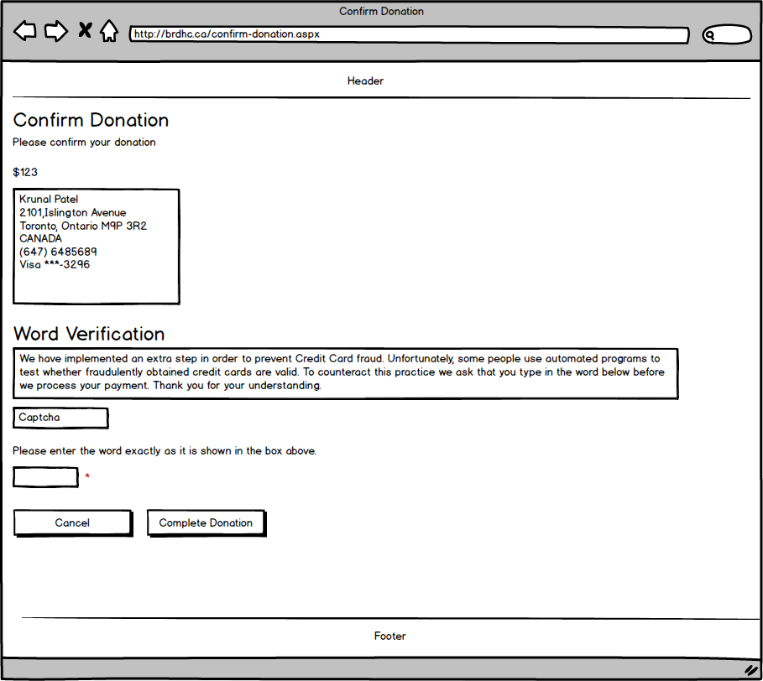

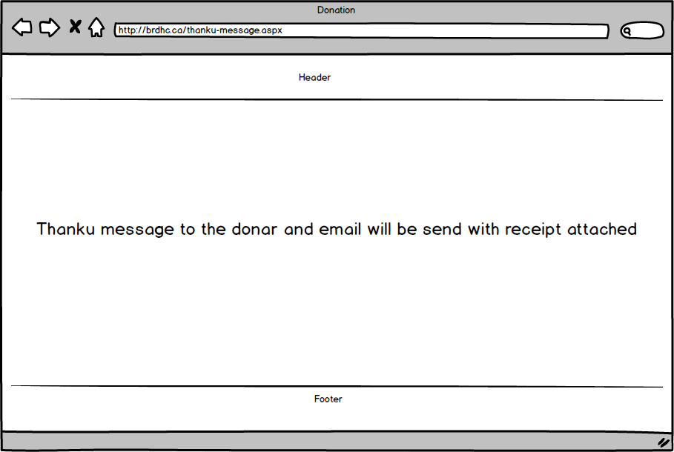

**Admin view**: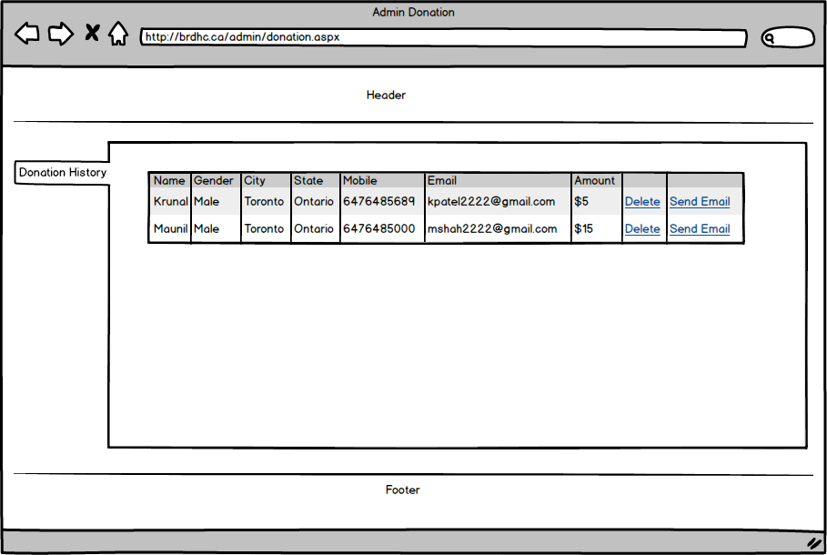

# Feature Feedback Survey (Krunal):

Using this feature a person can give feedback about the hospital and the hospital website. This will help the management to improve in both if required. The user just have to fill a form and submit it which will be stored in the database. When the user submits the survey they will get an email thanking them.

On the admin side he can view all the surveys submitted by people and delete them if not required.

|  |  |
| --- | --- |
| Primary Key | Numeric |
| Name | Varchar(50) |
| Gender | Char(10) |
| City | Varchar(50) |
| State | Varchar(50) |
| Mobile | decimal |
| Email | Varchar(50) |
| Feedback | Varchar(max) |

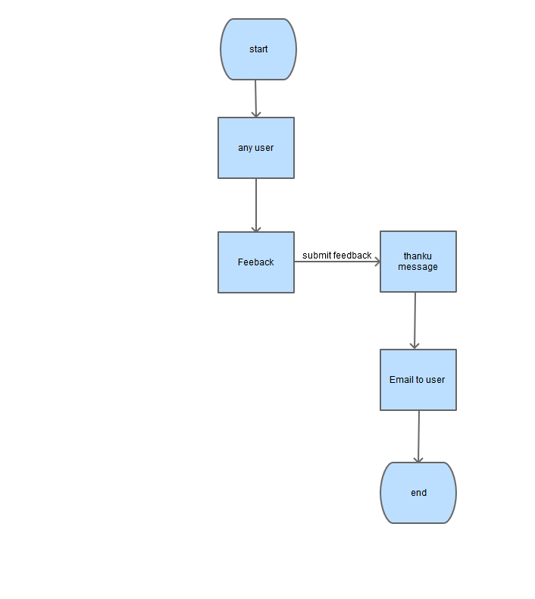

**Flow chart** **Feedback-Survey User view**

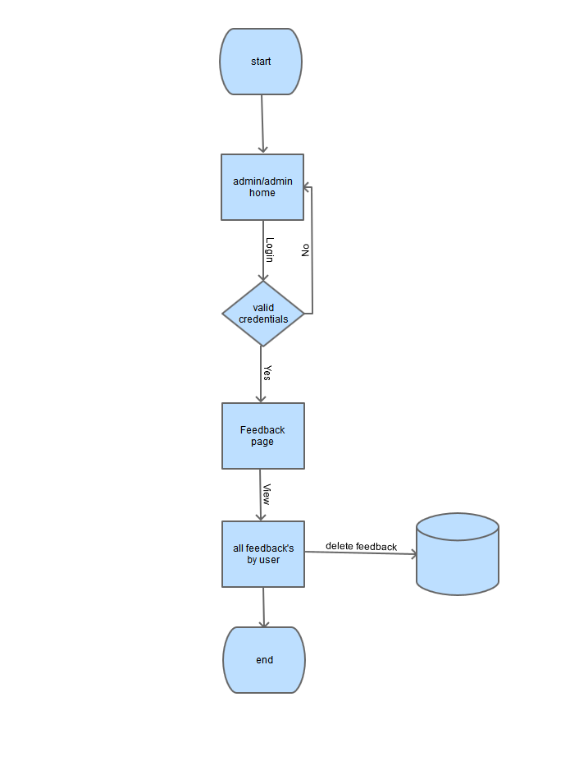

**Flow chart** **Feedback Survey Admin**

**Wireframes:**

**User view**

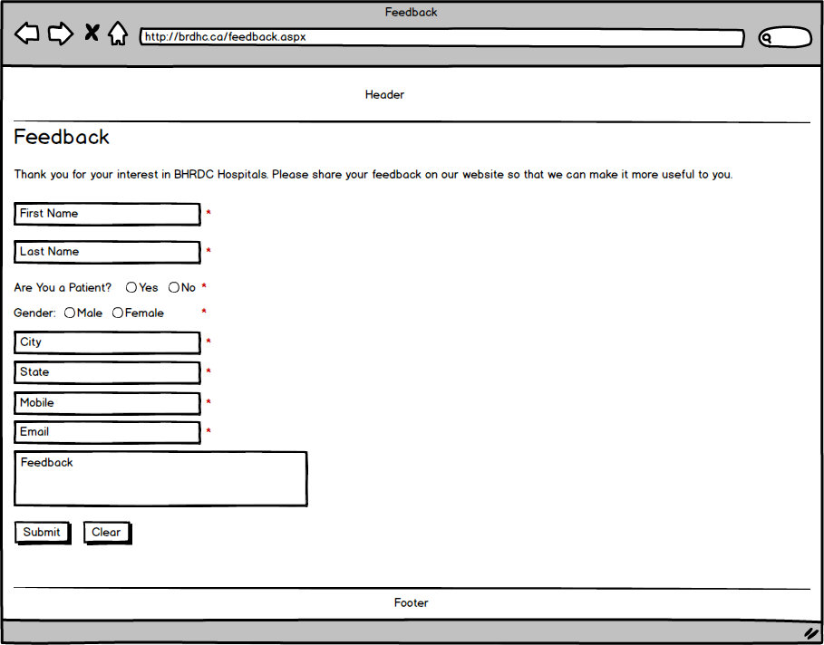

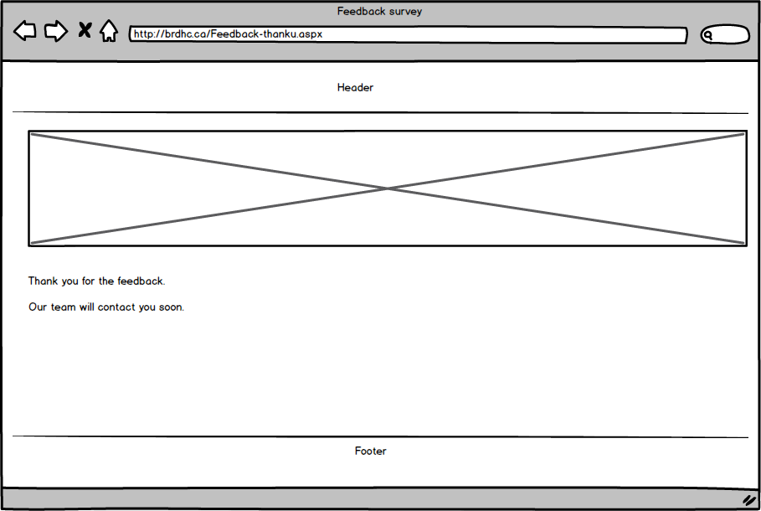

**Admin view**

